BaiduBCS

Added and verified on April 29, 2018.

1. To register an account, follow the link <http://developer.baidu.com> and click on the specified button.

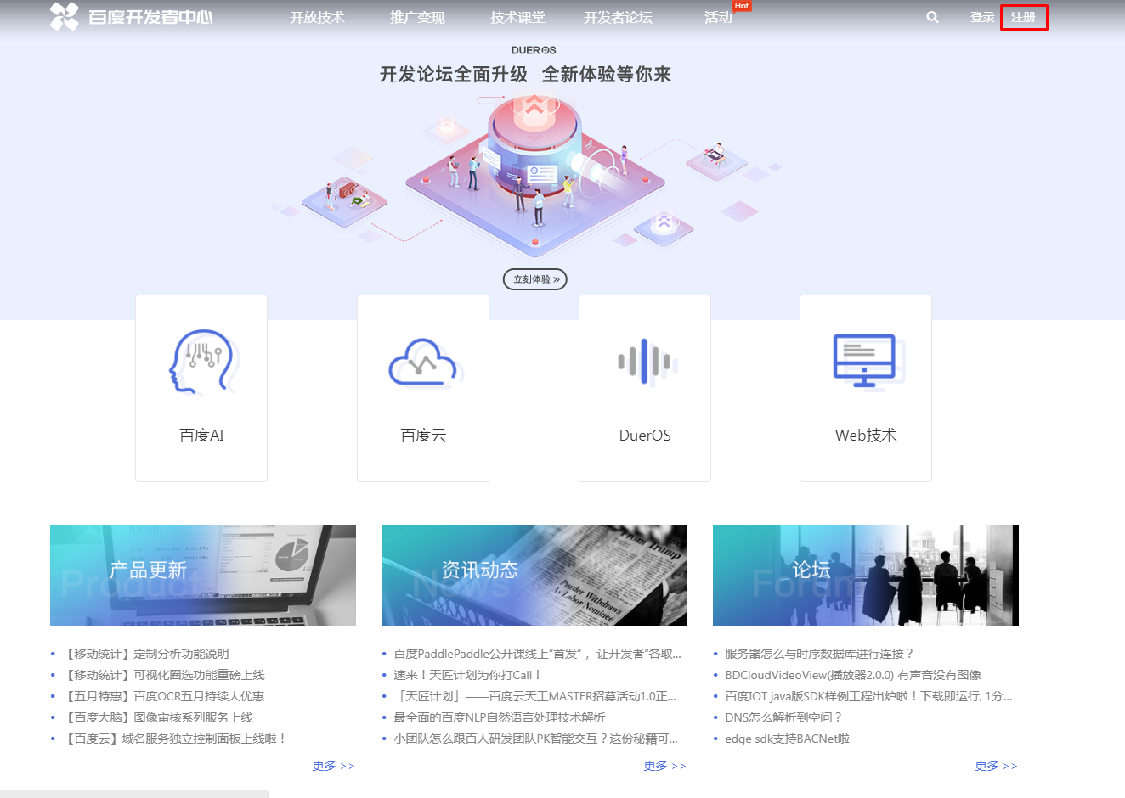

2. Fill out the form and confirm the entered data.

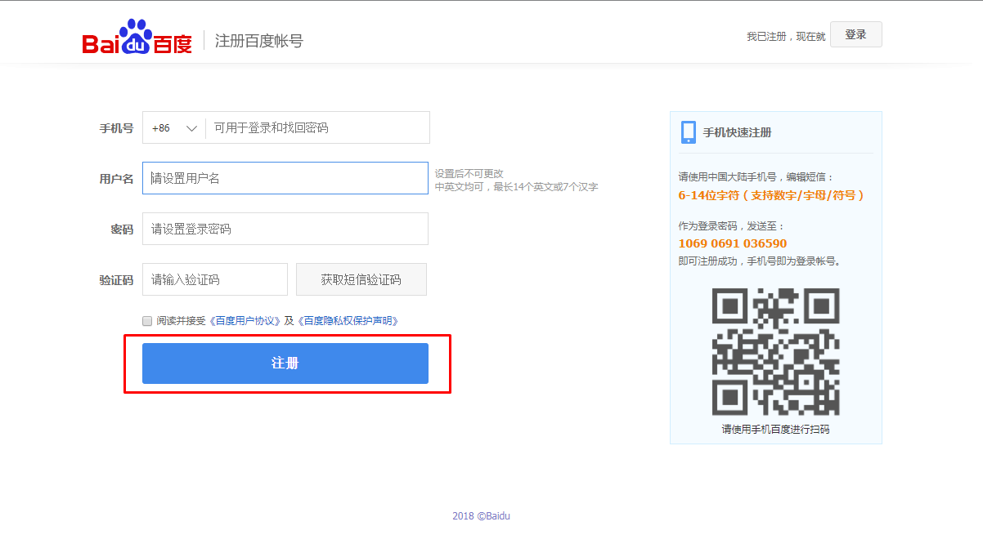

3. Next, you will receive a message about the successful registration.

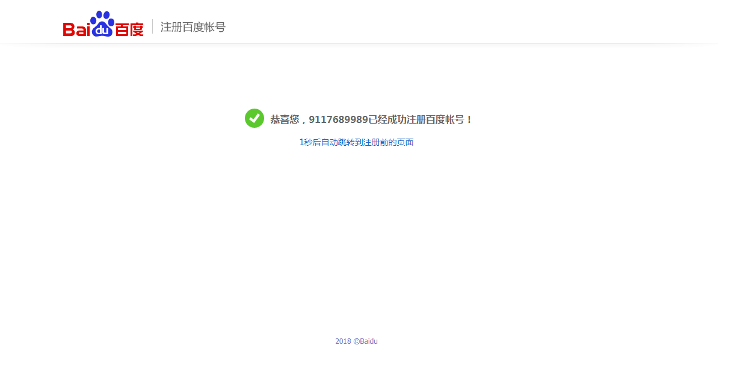

4. Click on the link shown in the screenshot.

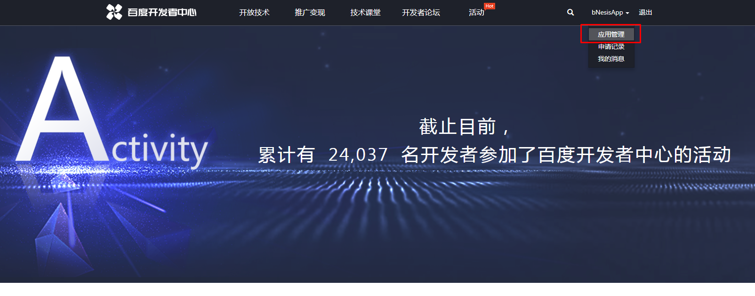

5. Fill in registration details.

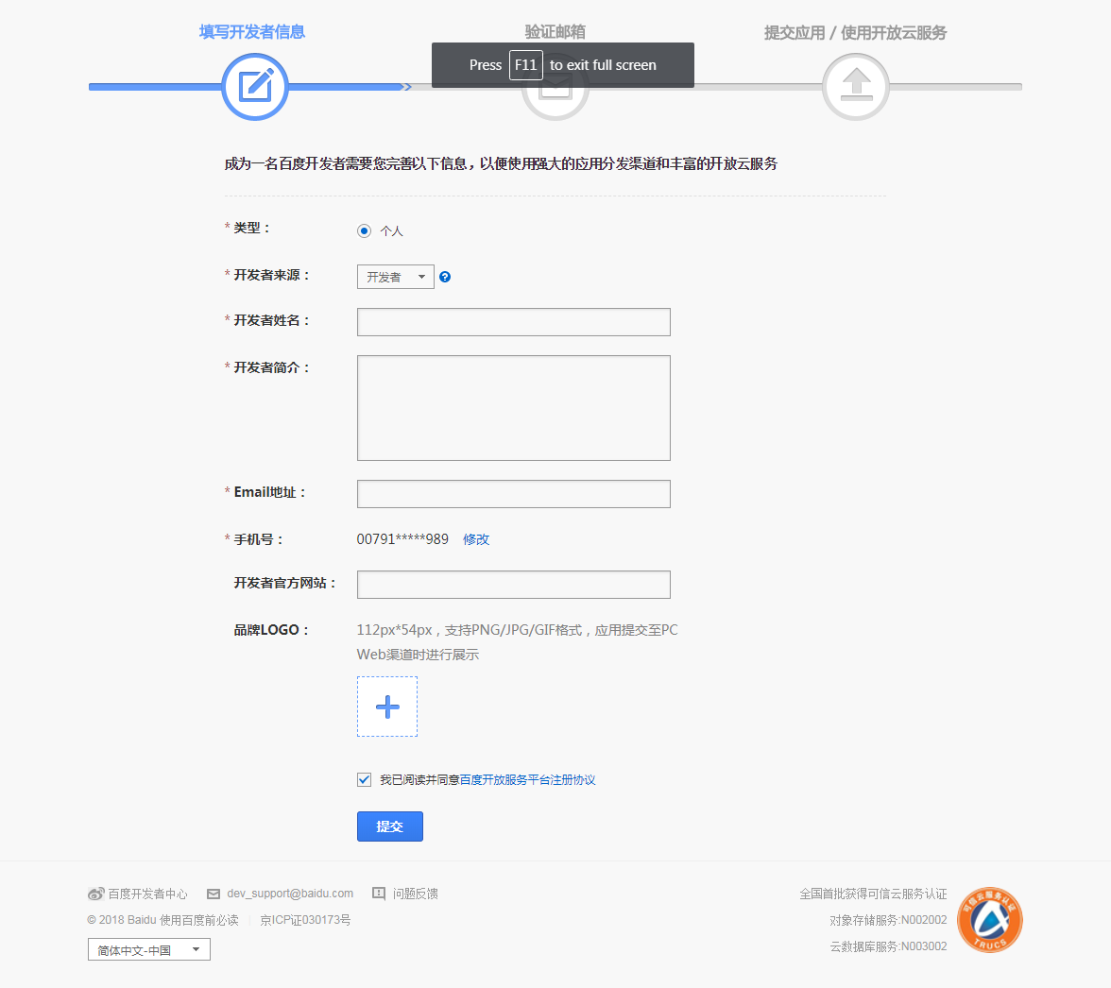

6. Click on the button shown in the screenshot.

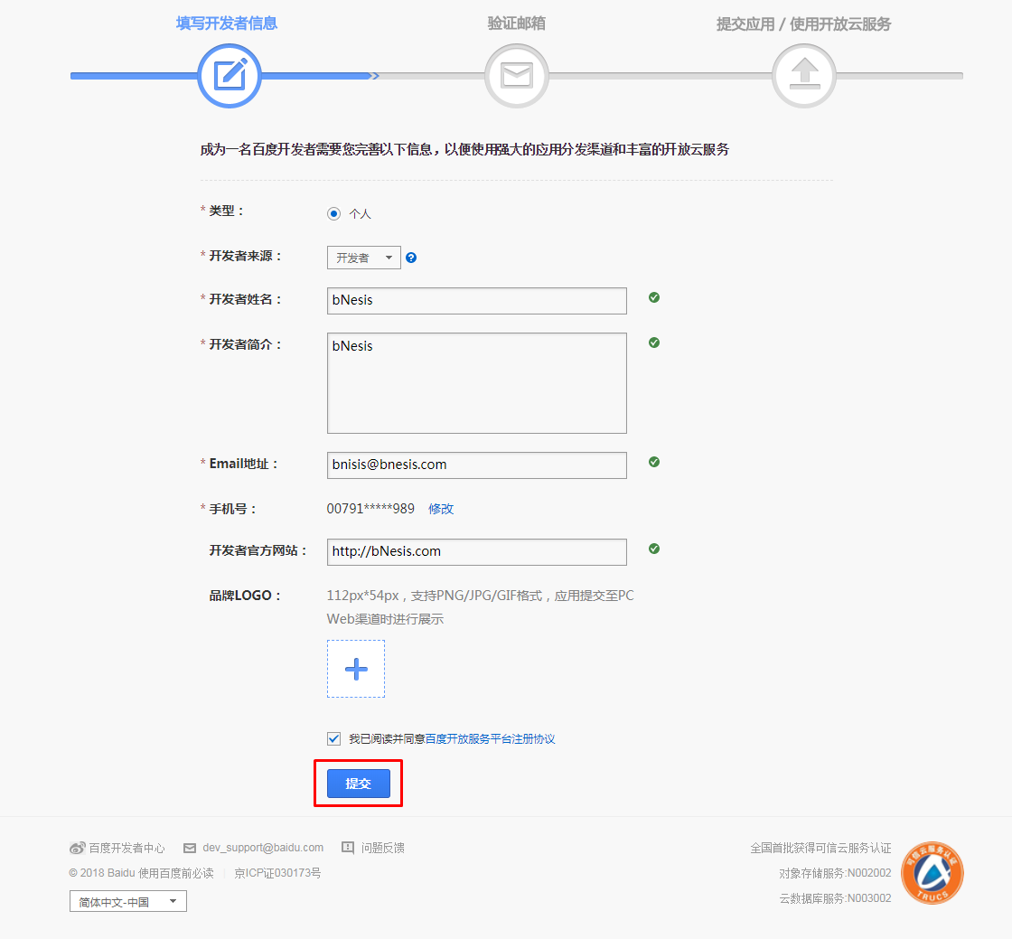

7. Activate the account by clicking on the link inside the email sent by the service to the specified email address.

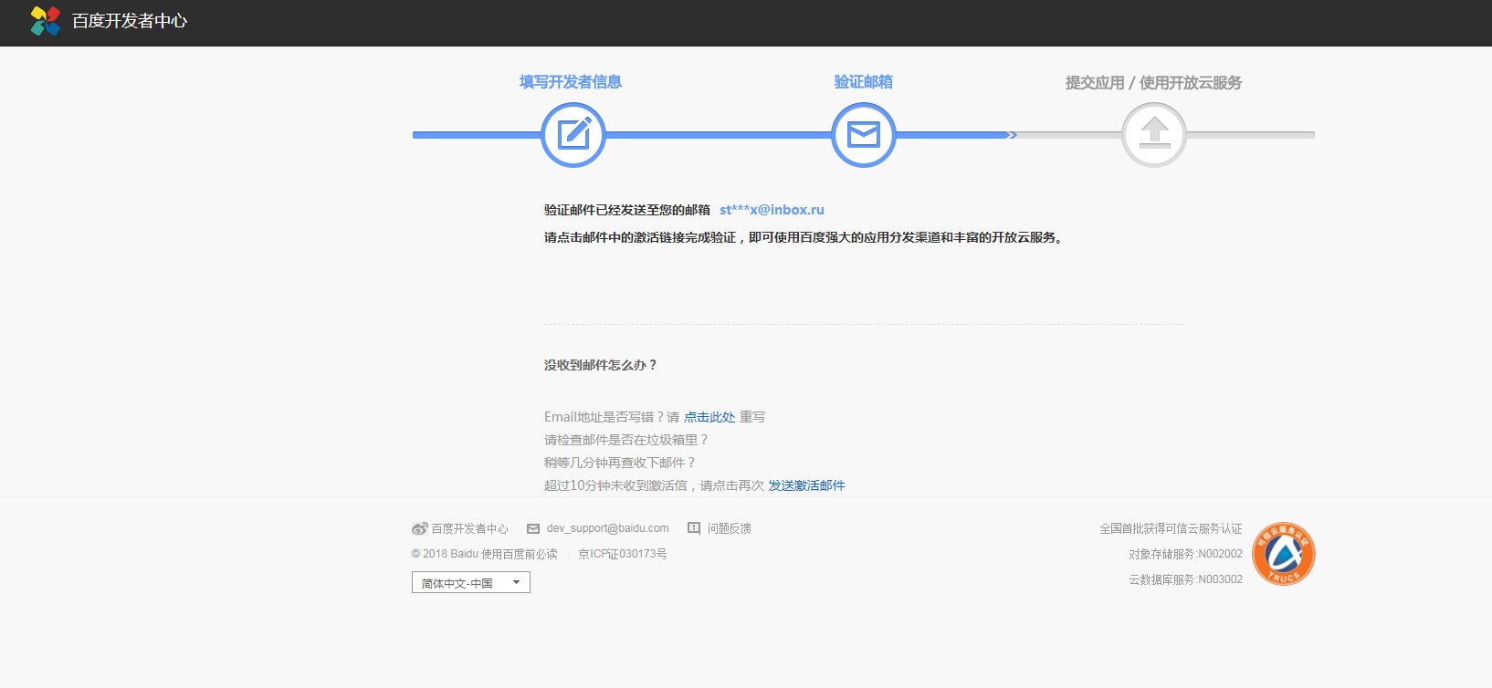

8. Click on the link on the screenshot.

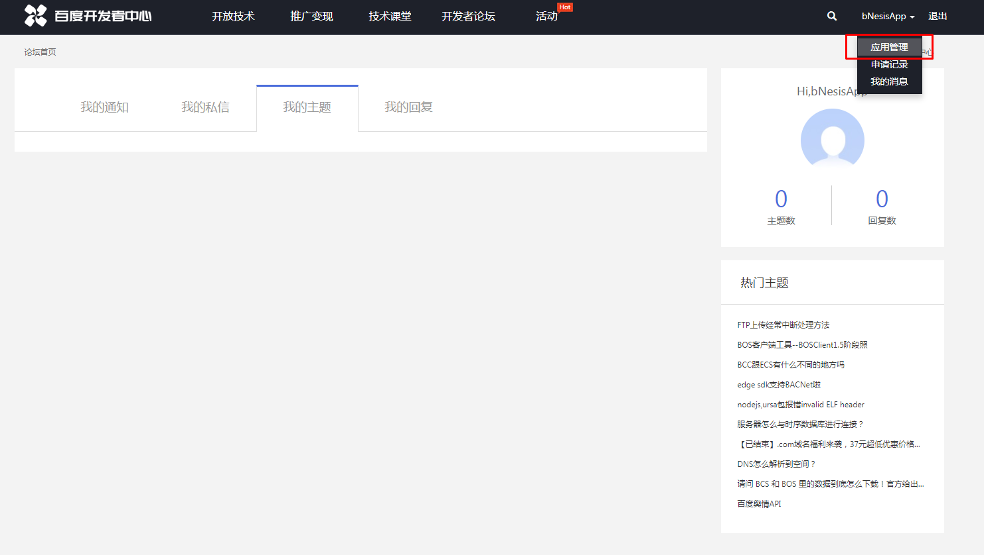

9. Click on the button indicated in the screenshot.

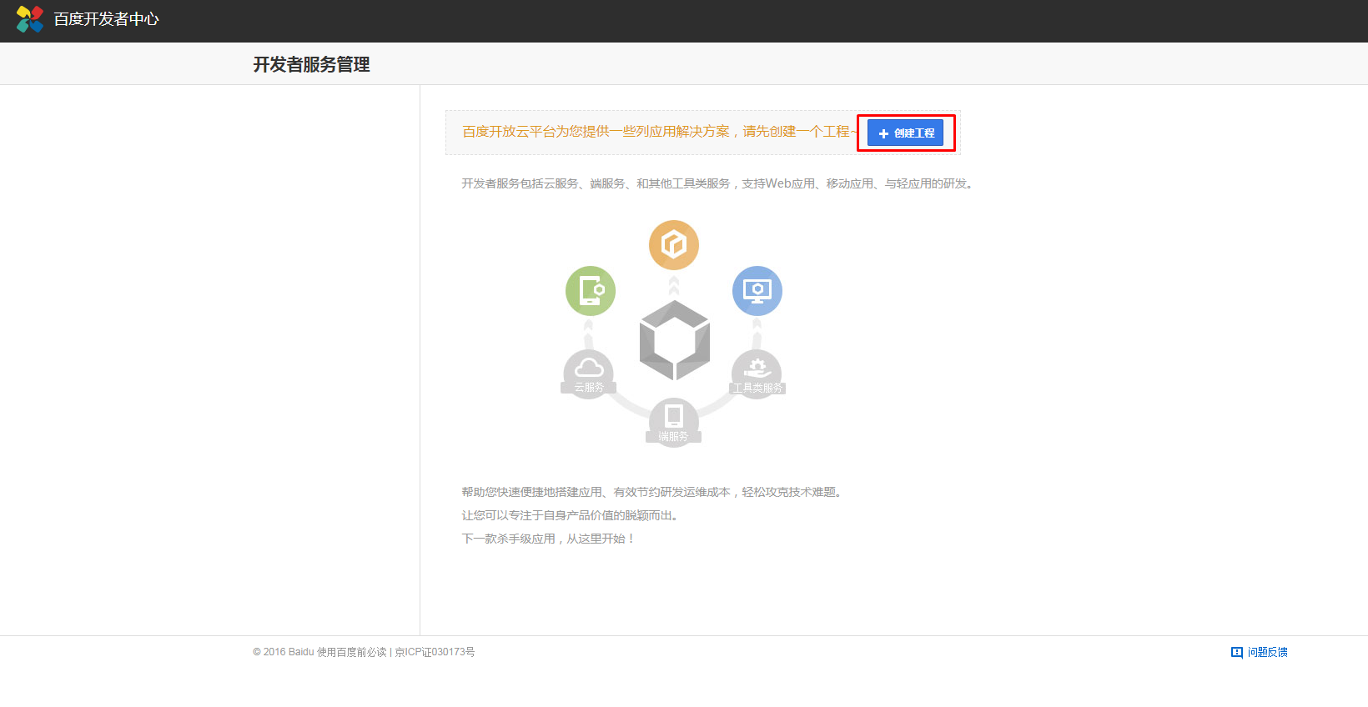

10. Fill out the form and click on the button indicated in the screenshot.

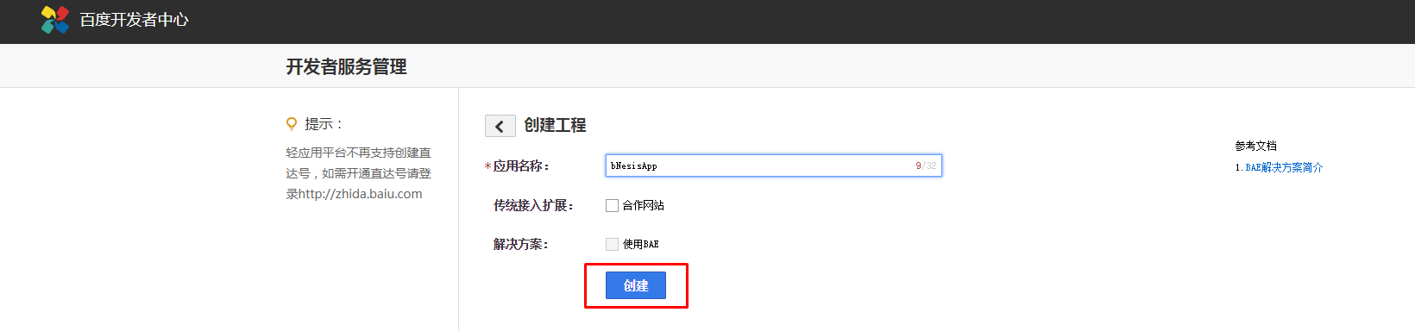

11. Further you can get "API Key" and "Secret Key" necessary for authorization in the service.

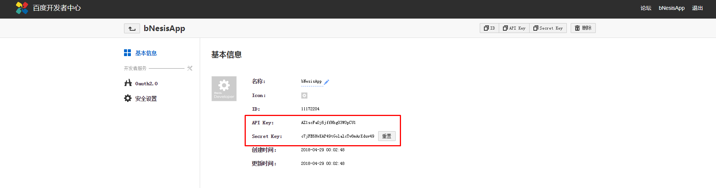

12. Click on the button on the screenshot to add the Redirect URL.

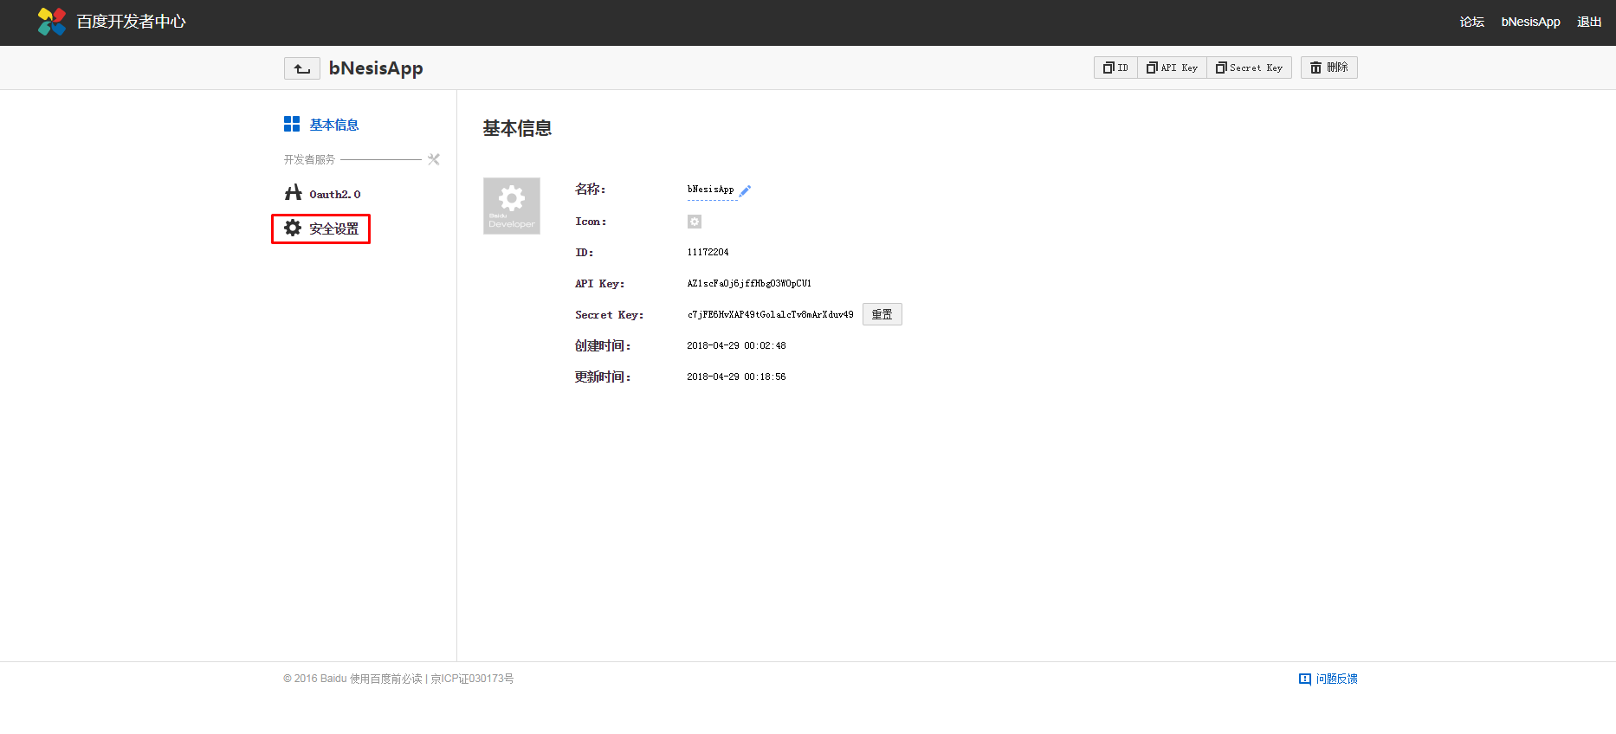

13. Enter the data and to confirm them, click on the button on the screenshot.

